# DATABASE SYSTEM PRACTICUM REPORT

# MODULE 10

**SubQuery**



**CREATED BY :**

**KURNIAWAN BAGASKARA**

**L200214253**

# INFORMATICS STUDY

# PROGRAM

**FACULTY OF COMMUNICATION AND INFORMATION SCIENCE MUHAMMADIYAH SURAKARTA UNIVERSITY**

PRACTICE :

5 .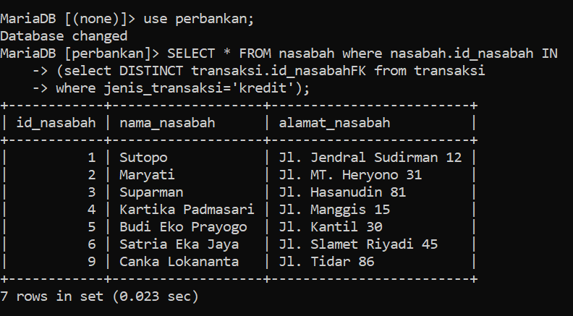

6 . 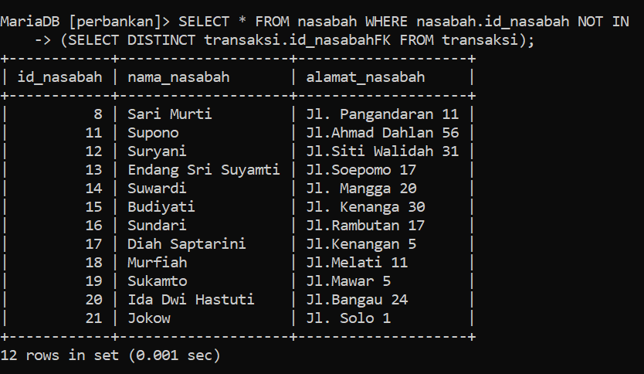

1. 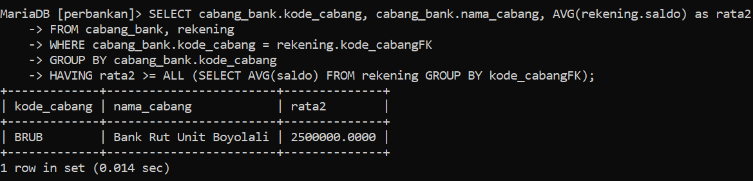
2. 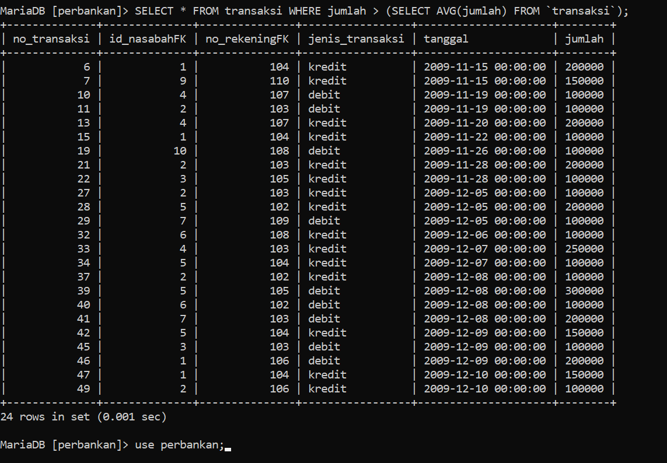

TASK:

1. 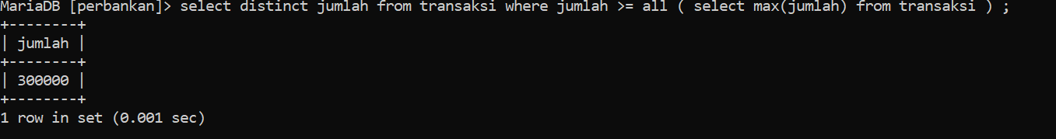
2. 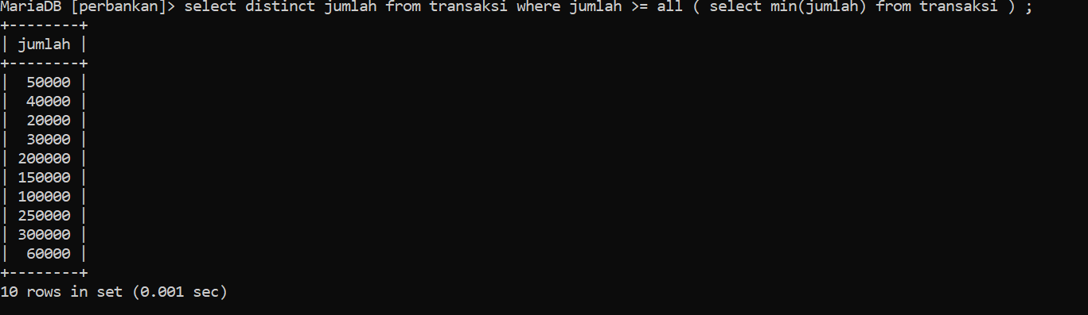
3. 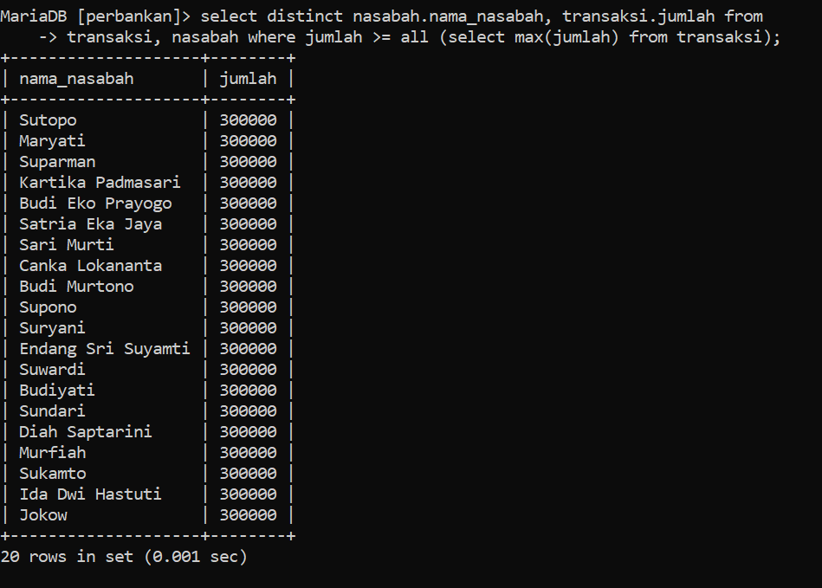
4. 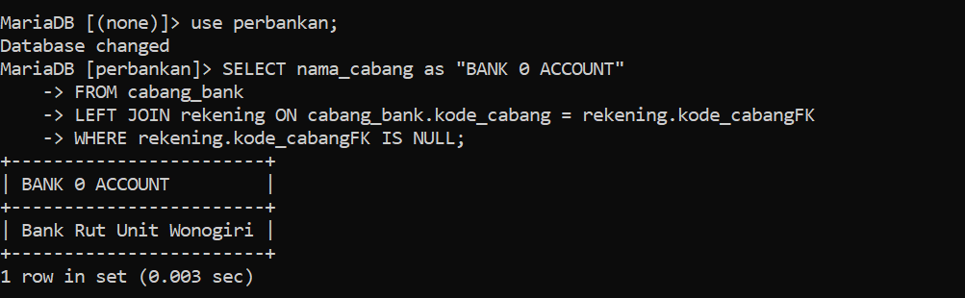
5. 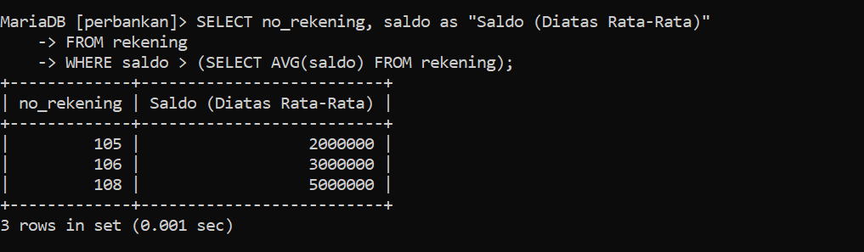
6. A. Make a query displaying the name of the customer with the largest balance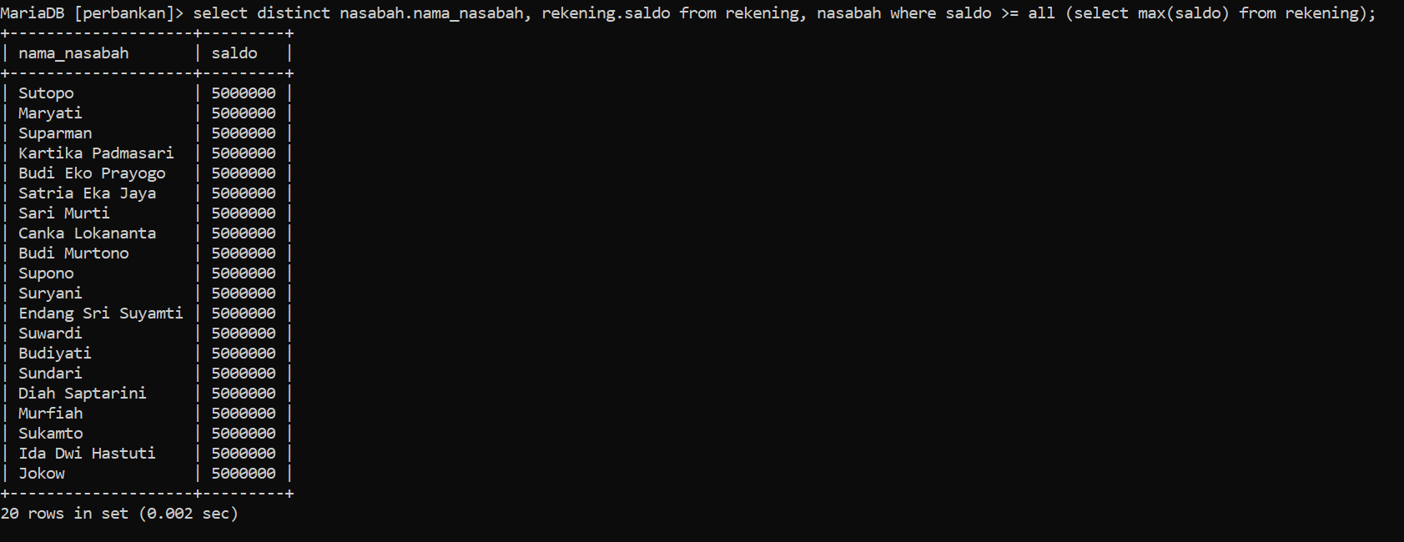
7. Make a query displaying the name of the customer with the smallest balance 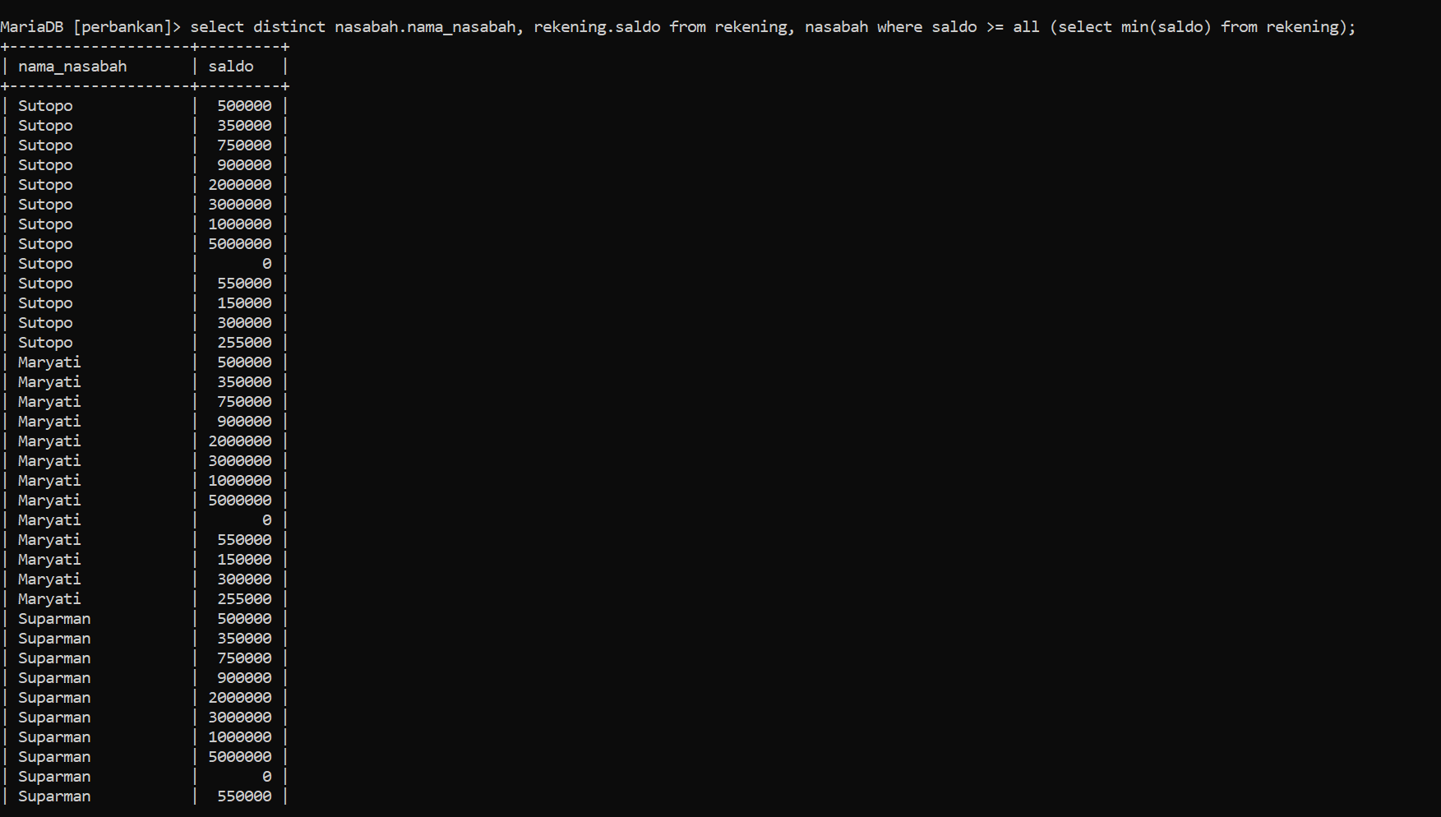
8. Make a query displaying the names of customers with a balance above the average 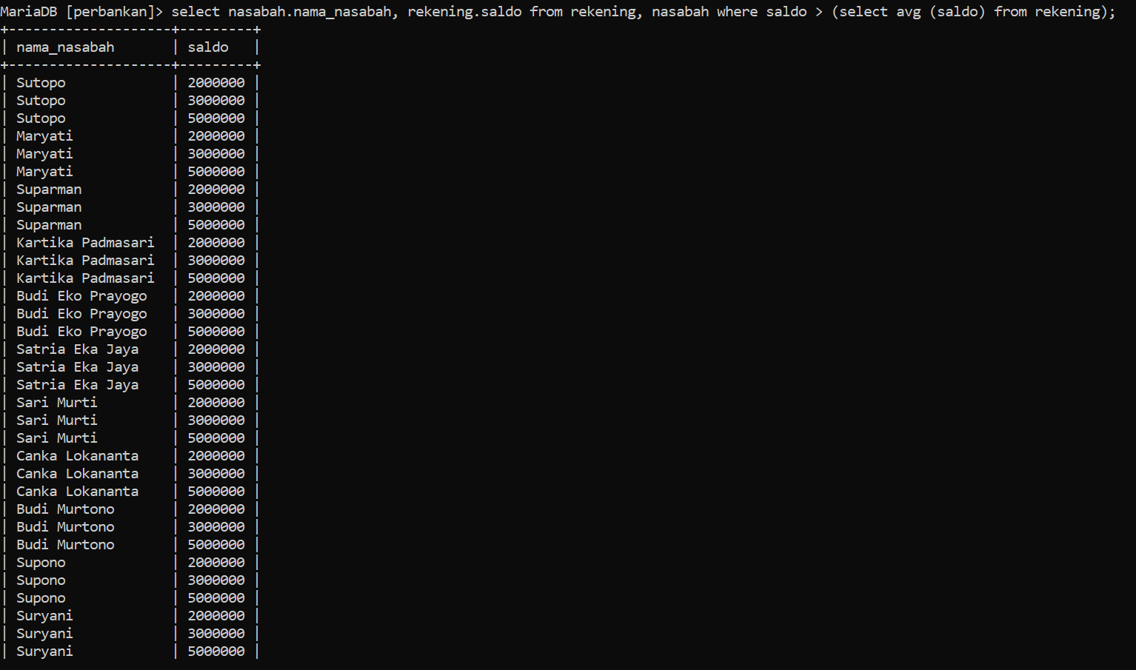
9. Make a query displaying the names of customers with a balance below the average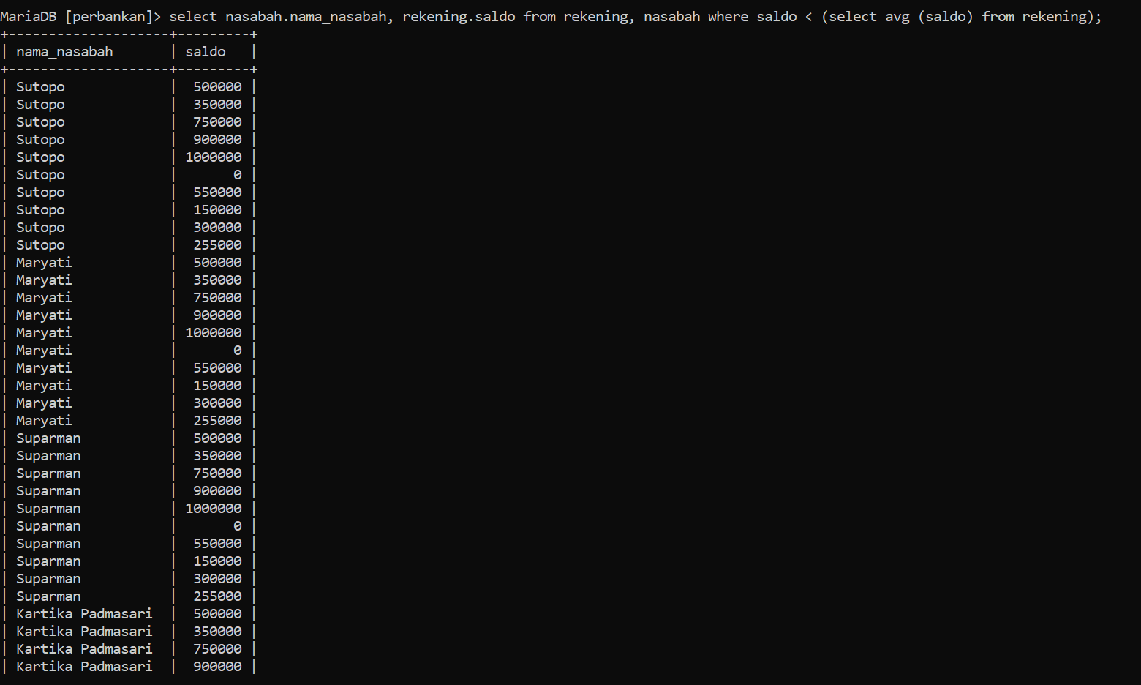
10. Make a query displaying the name of the bank branch that has the account number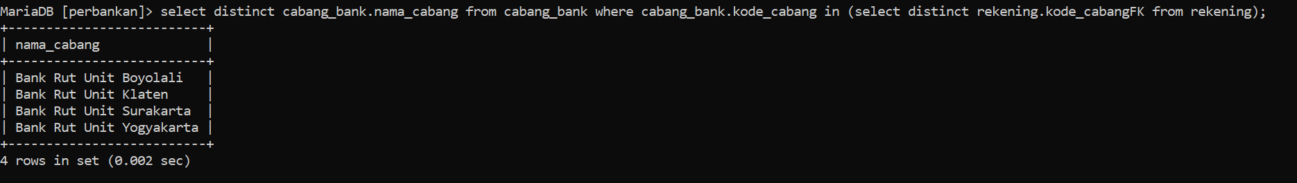

Task EXTRA

1. 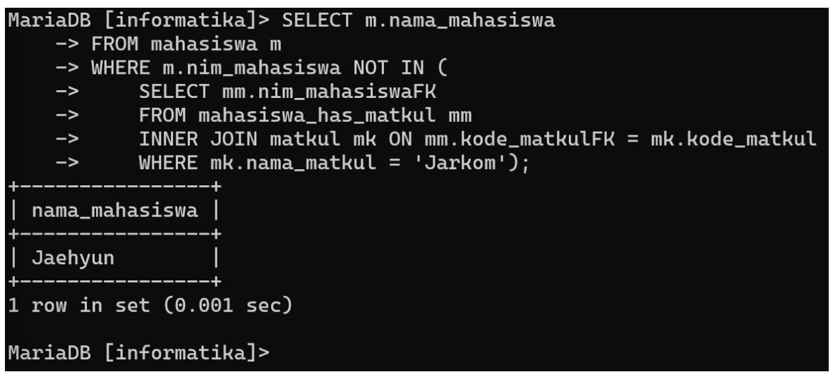
2. 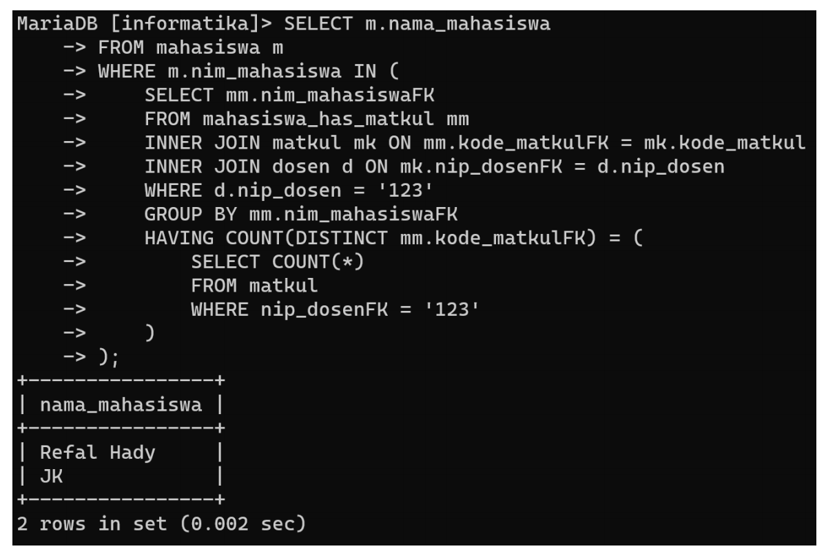
3. 